Low Level Design - <Interview Management System>

**Document ID:** < Use Case Number >

**Last Reviewed by:** <user name>

**Version:** 2.1

**Date: Jan 25, 2022**

Table of Contents

1. Introduction 2

2. Design Approach 2

2.1 Approach 1 2

2.2 Approach 2 2

2.3 Selected Approach 2

3. Class Diagram 2

4. Detailed Interaction Diagram 2

5. Presentation Layer 2

5.1 Screens 2

5.2 Reports 3

6. Business Layer 3

7. Database Layer 4

8. Detailed Design to Functional Requirement Cross Reference Matrix 4

9. Build Process 4

10. Definitions and Acronyms 4

# Introduction

<Give an overview of the document>

# Design Approach

<List the approaches analyzed to provide a solution for the requirement under consideration>

## Approach 1

<Details of the approach>

## Approach 2

<Details of the approach>

## Selected Approach

<Selected approach with the reason for selection must be provided in this section>

# Class Diagram

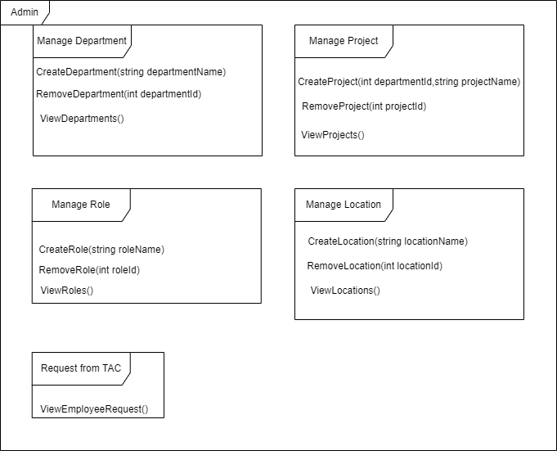

# Detailed Interaction Diagram

<The Sequence diagram for all the identified use case scenarios from the requirements using the classes detailed in the class diagram section>

# 5. Presentation Layer

# 5.1 Screen 1: Login Page

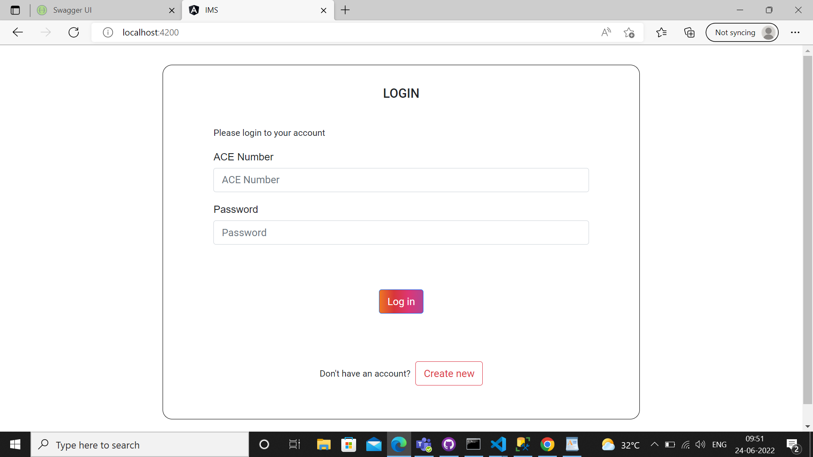

|  |  |
| --- | --- |
| Description | Purpose of the screen: Here the user can login to his/her account to view the application after successful registration. |
| **Security Group** | List the security groups that may use the screen |
| **Data** | Users have to enter their credentials like ACE number and password, once the credentials matched user can able to view the home page otherwise, the user stay on the login page. |
| **Actions** | Login Button: User have to enter their credentials, then have to press login to view the home page |

## Screen 2: Employee request

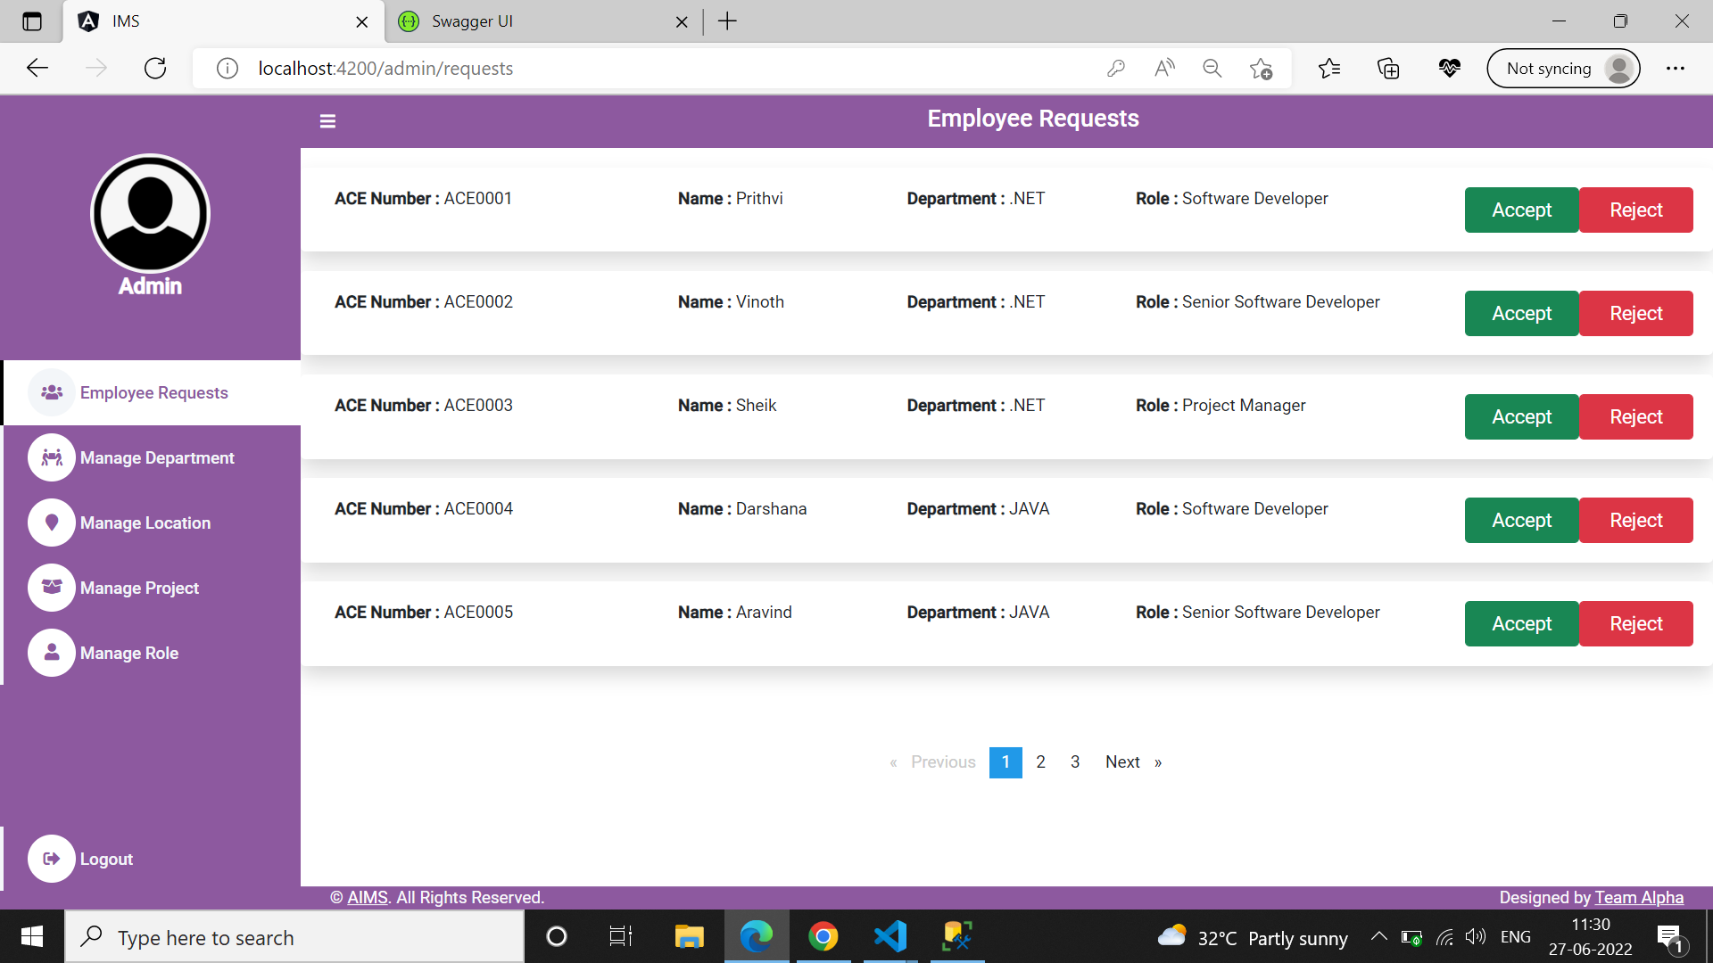

|  |  |
| --- | --- |
| Description | Purpose of the screen: Here admin can able to view requests received from the employee. |
| **Security Group** | List the security groups that may use the screen |
| **Data** | By clicking “Employee Requests “in navbar, admin can able to view Request received from the employee and admin can able to accept or reject the request. |
| **Actions** | Accept Button: Admin can accept the request received from the employee by clicking “Accept” button.  Reject Button: By clicking “Reject” button to reject the request received from the employee. |

## Screen 3: Manage Department

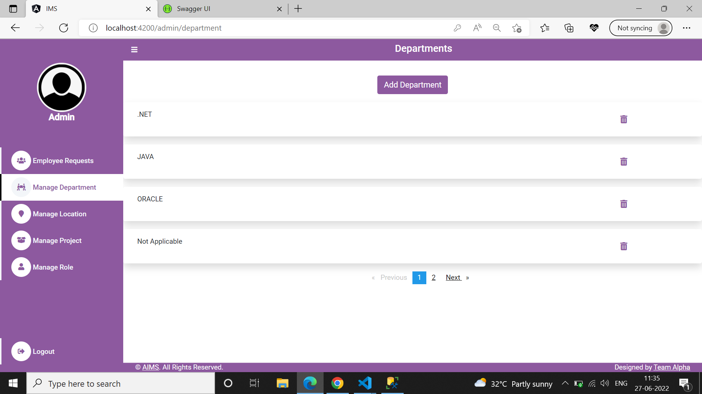

|  |  |
| --- | --- |
| Description | Purpose of the screen: Here the user can view the list of departments and is able to add and remove departments. |
| **Security Group** | List the security groups that may use the screen |
| **Data** |  |
| **Actions** | By clicking “Manage Department “in navbar, admin can able to view list of available departments. |

## Screen 4: Remove Department

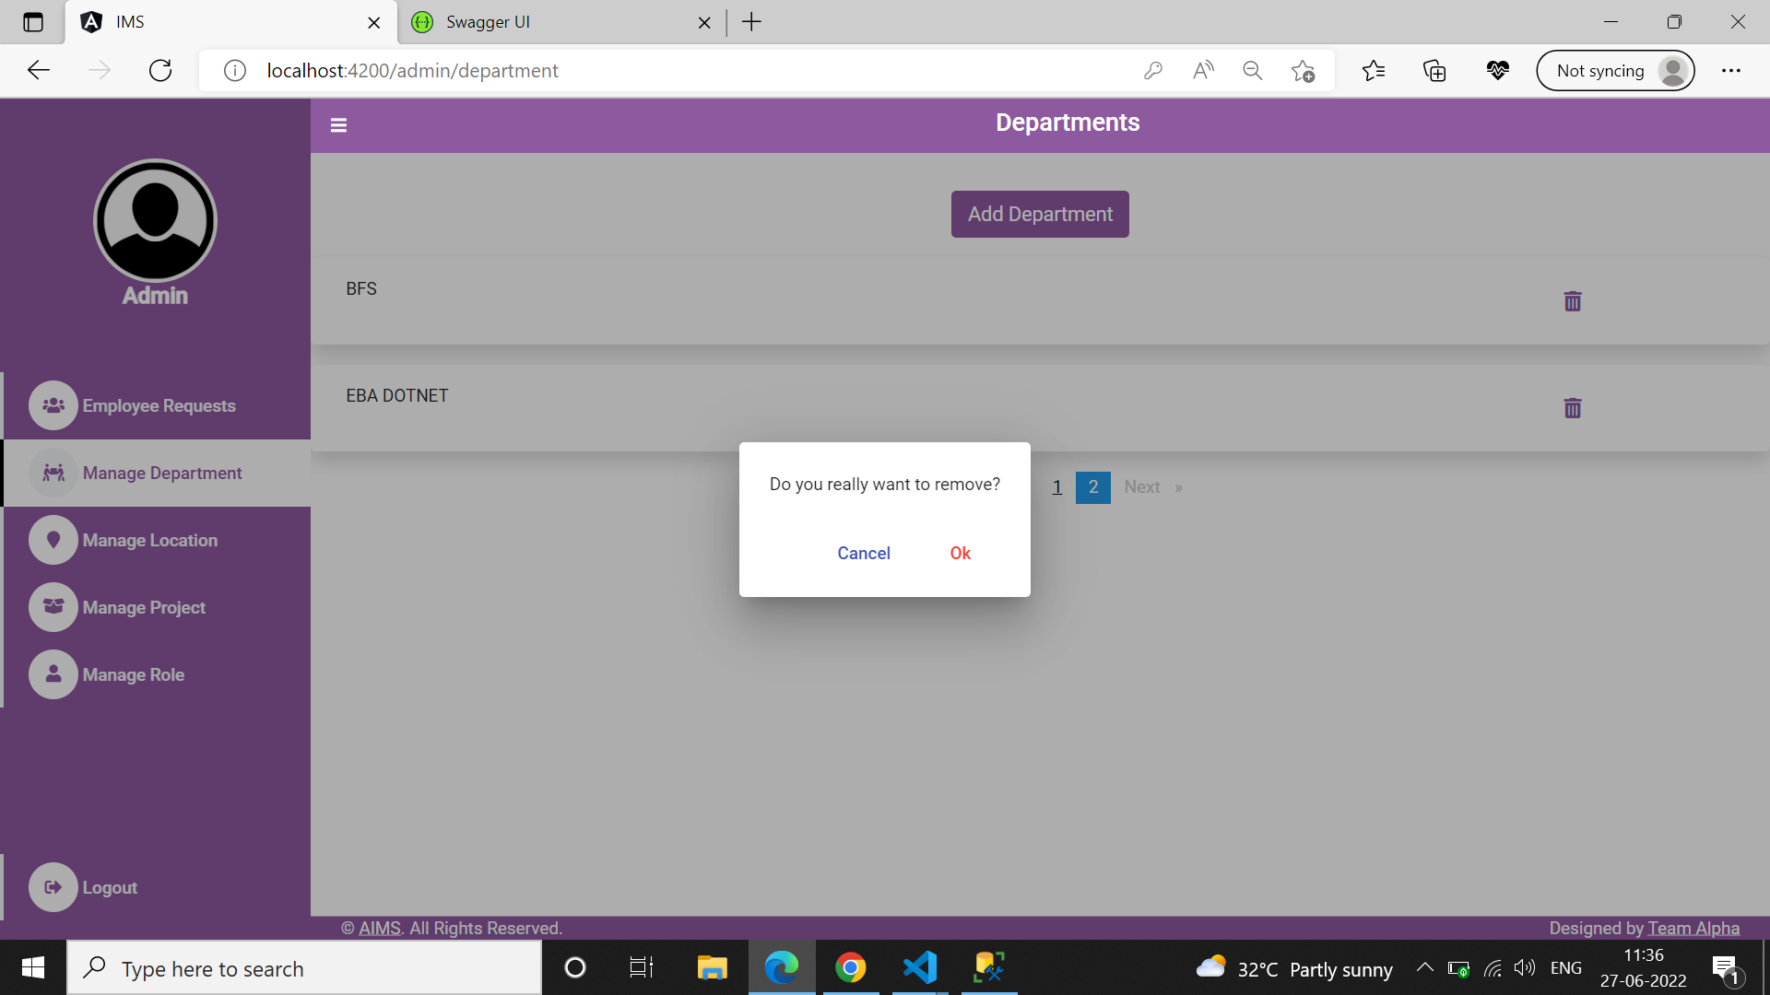

|  |  |
| --- | --- |
| Description | Purpose of the screen: Here the user can view the list of departments and is able to add and remove departments. |
| **Security Group** | List the security groups that may use the screen |
| **Data** |  |
| **Actions** | By clicking “Remove icon” admin prompts for confirmation, once he/she click “ok” particular department will get removed. |

## Screen 5: Add Department

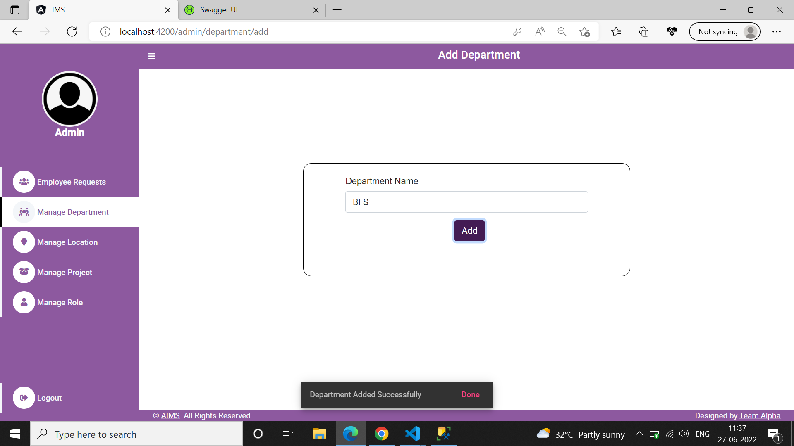

|  |  |
| --- | --- |
| Description | Purpose of the screen: Here admin able to add the departments. |
| **Security Group** | List the security groups that may use the screen |
| **Data** | Admin have to enter department name that he/she wants to add and have to press add button. Required field validations and Department already exist validations are done here. |
| **Actions** | Add Button: Admin have to enter department name, then have to press add button to add the department. Once it’s added, it notifies “Location added Successfully”. |

**Screen 6: Manage Locations**

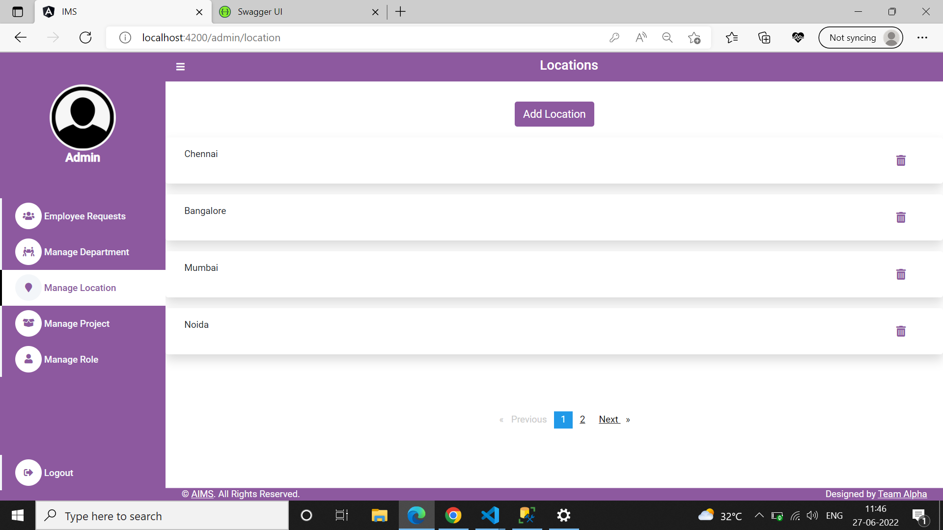

|  |  |
| --- | --- |
| Description | Purpose of the screen: Here the user can view the list of departments and is able to add and remove departments. |
| **Security Group** | List the security groups that may use the screen |
| **Data** |  |
| **Actions** | By clicking “Manage Location” in the navbar, admin can able to view the list of locations. |

## Screen 7: Remove Location

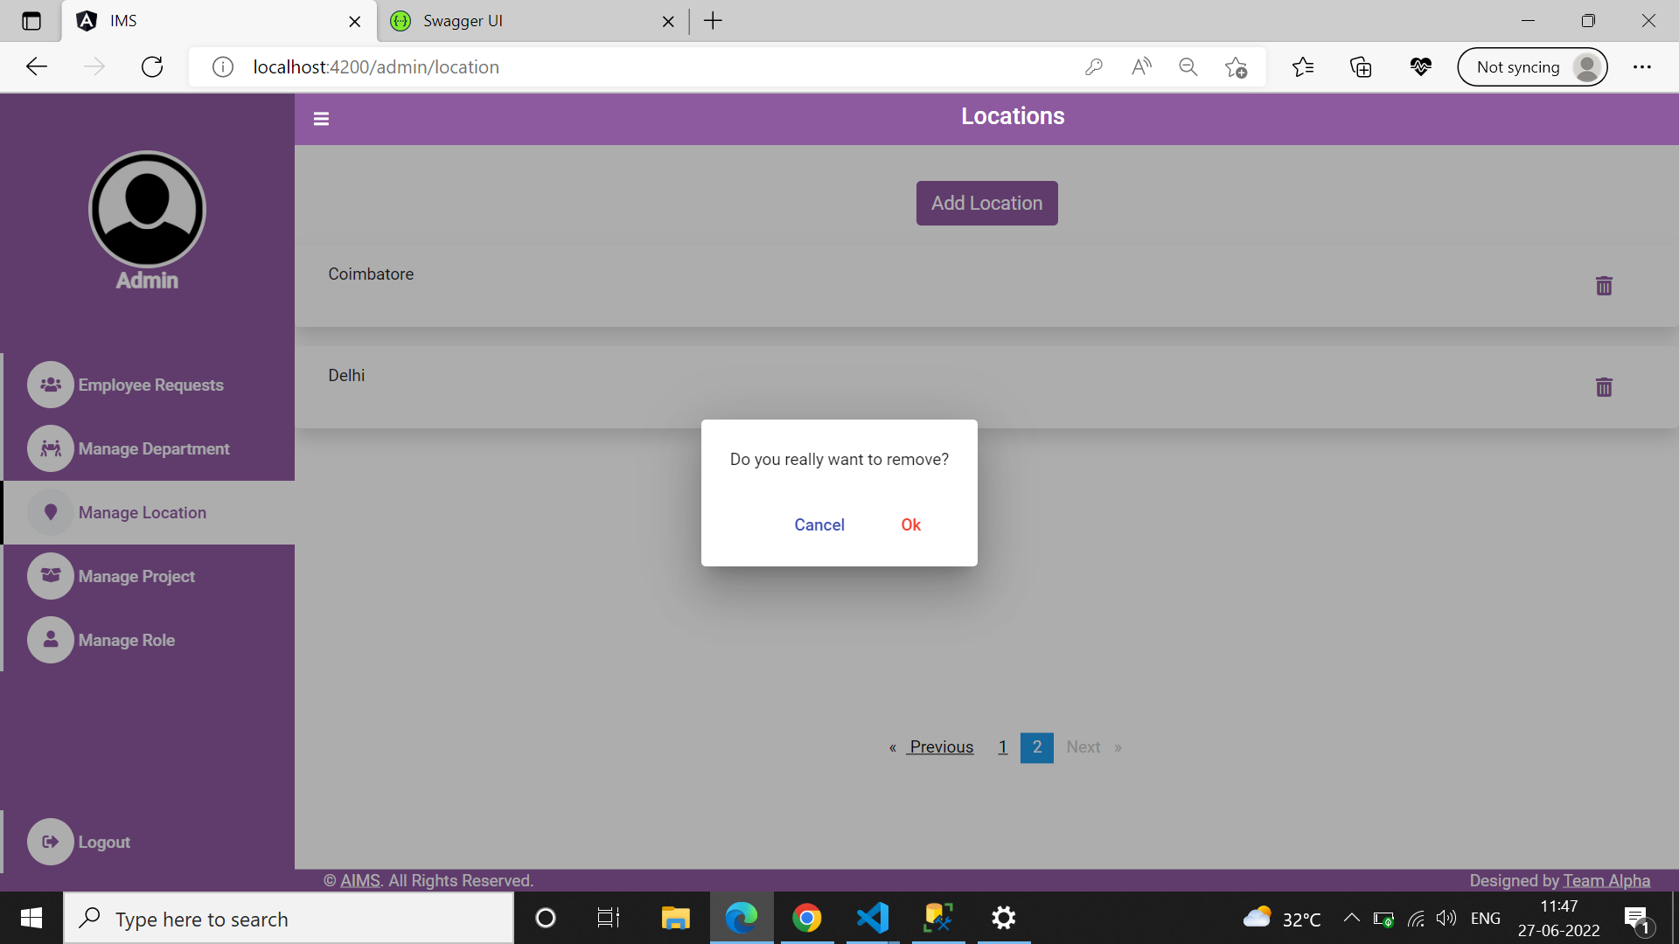

|  |  |
| --- | --- |
| Description | Purpose of the screen: Here the user can view the list of Locations and is able to add and remove departments. |
| **Security Group** | List the security groups that may use the screen |
| **Data** |  |
| **Actions** | By clicking “Remove icon” admin prompts for confirmation, once he/she click “ok” particular location will get removed. |

## Screen 8: Add Location

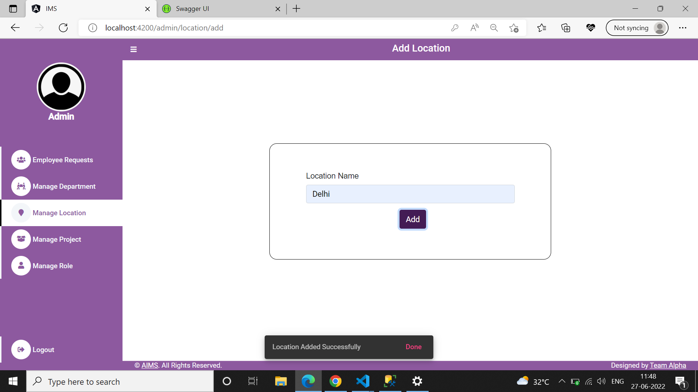

|  |  |
| --- | --- |
| Description | Purpose of the screen: Here admin able to add the Locations. |
| **Security Group** | List the security groups that may use the screen |
| **Data** | Admin has to enter Location that he/she wants to add and have to press add button. Required field validations and location already exist validations are done here. |
| **Actions** | Add Button: Admin have to enter Location name, then have to press “Add” button to add the Location. Once it’s added it notifies “Location added Successfully”. |

**Screen 9: Manage Projects**

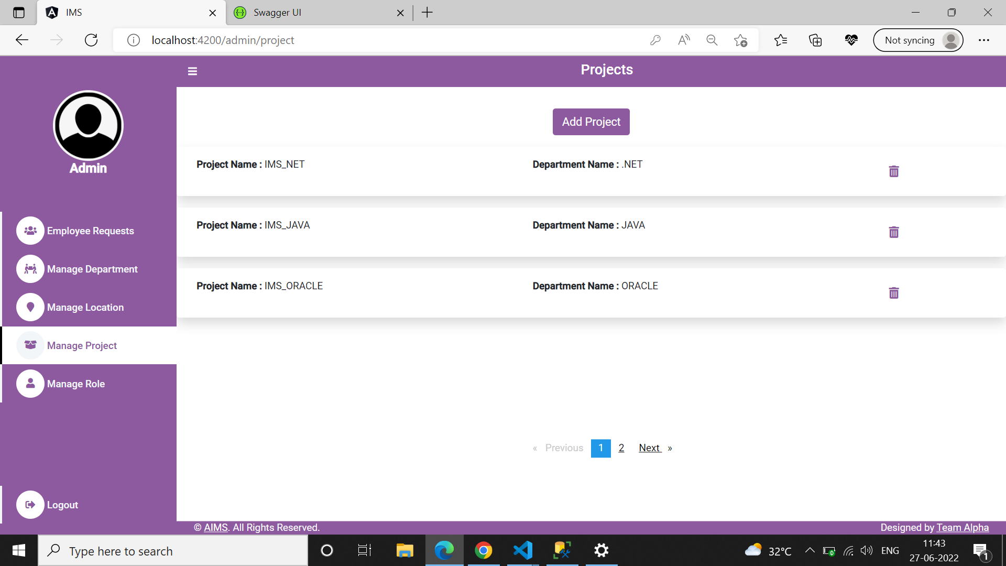

|  |  |
| --- | --- |
| Description | Purpose of the screen: Here the user can view the list of Projects and is able to add and remove departments. |
| **Security Group** | List the security groups that may use the screen |
| **Data** |  |
| **Actions** | By Clicking “Manage Project” in the navbar, admin can able to view the list of projects. |

## Screen 10: Remove Project

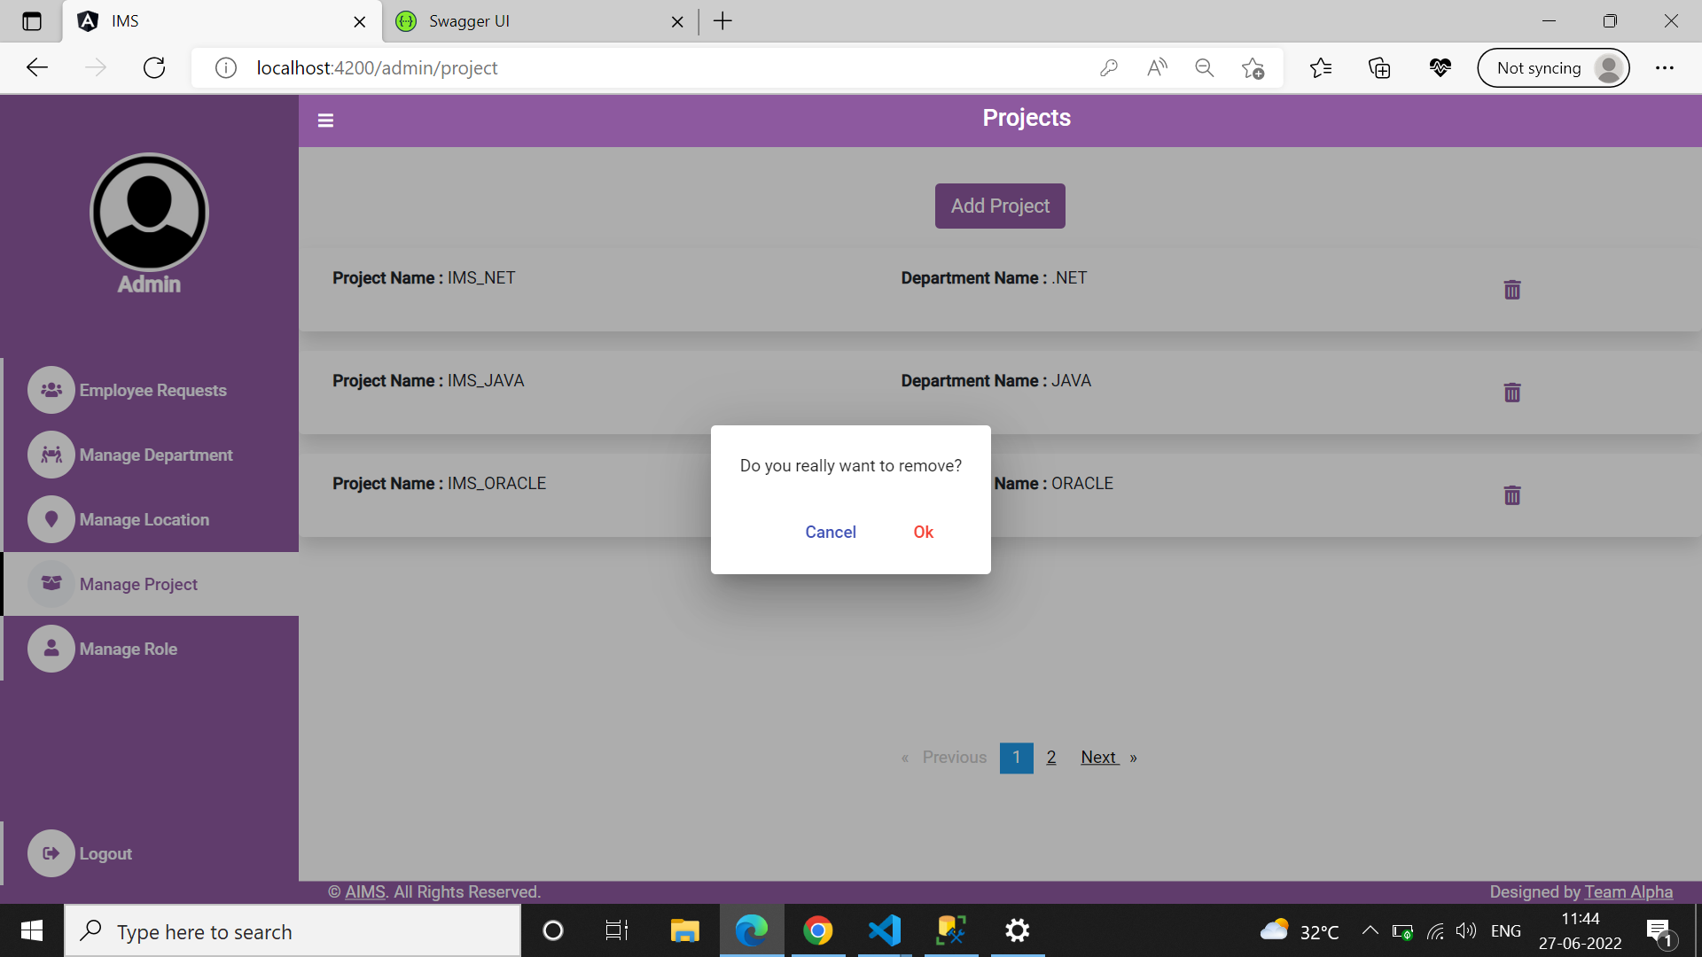

|  |  |
| --- | --- |
| Description | Purpose of the screen: Here the user can view the list of Projects and is able to add and remove departments. |
| **Security Group** | List the security groups that may use the screen |
| **Data** |  |
| **Actions** | By clicking “Remove icon” admin prompts for confirmation, once he/she click “ok” particular project will get removed. |

## Screen 11: Add Project

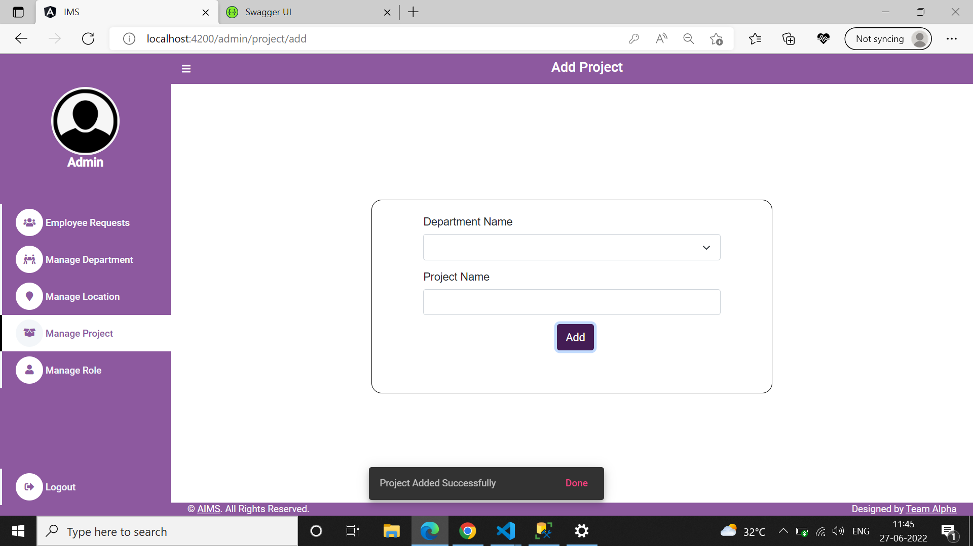

|  |  |
| --- | --- |
| Description | Purpose of the screen: Here admin able to add the Projects. |
| **Security Group** | List the security groups that may use the screen |
| **Data** | Admin have to select the department in which he/she wants to add project and enter project name, after that press add button. Required field validations are done here. |
| **Actions** | Add Button: Admin have to select the department from the list of department dropdown and have to enter the project name and then click “Add” to add the project. Once it’s added, it notifies “Project add Successfully”. |

## Screen 12: Manage Role

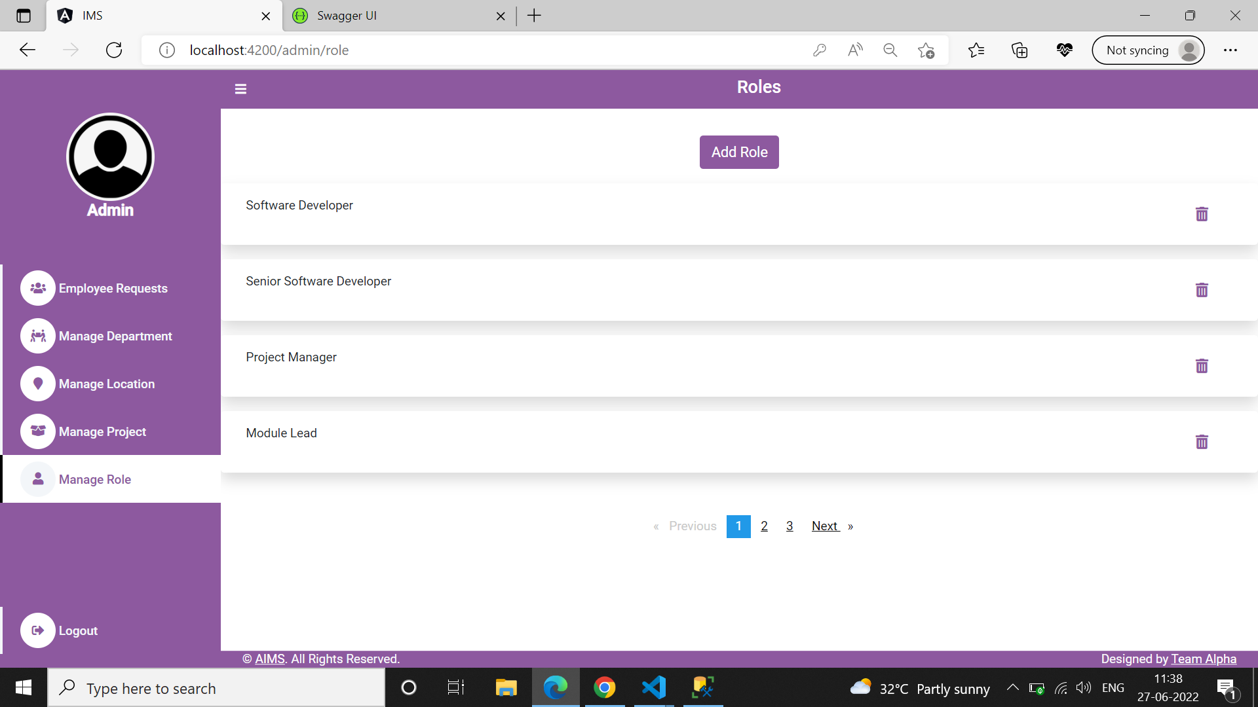

|  |  |
| --- | --- |
| Description | Purpose of the screen: Here the admin can view the list of roles and is able to add and remove Roles. |
| **Security Group** | List the security groups that may use the screen |
| **Data** |  |
| **Actions** | By clicking “Manage Role” in the navbar, admin can able to view the list of available roles. |

## Screen 13: Remove role

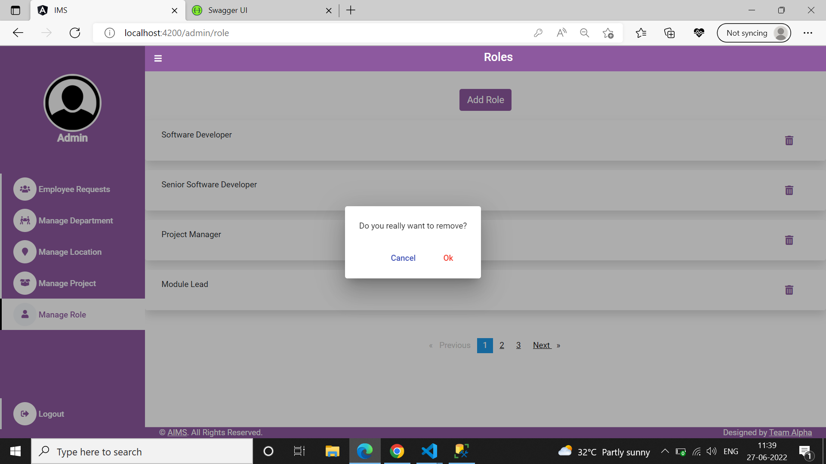

|  |  |
| --- | --- |
| Description | Purpose of the screen: Here the admin can view the list of roles and is able to add and remove Roles. |
| **Security Group** | List the security groups that may use the screen |
| **Data** |  |
| **Actions** | By clicking “Remove icon” admin prompts for confirmation, once he/she click “ok” particular role will get removed. |

## Screen 14: Add Role

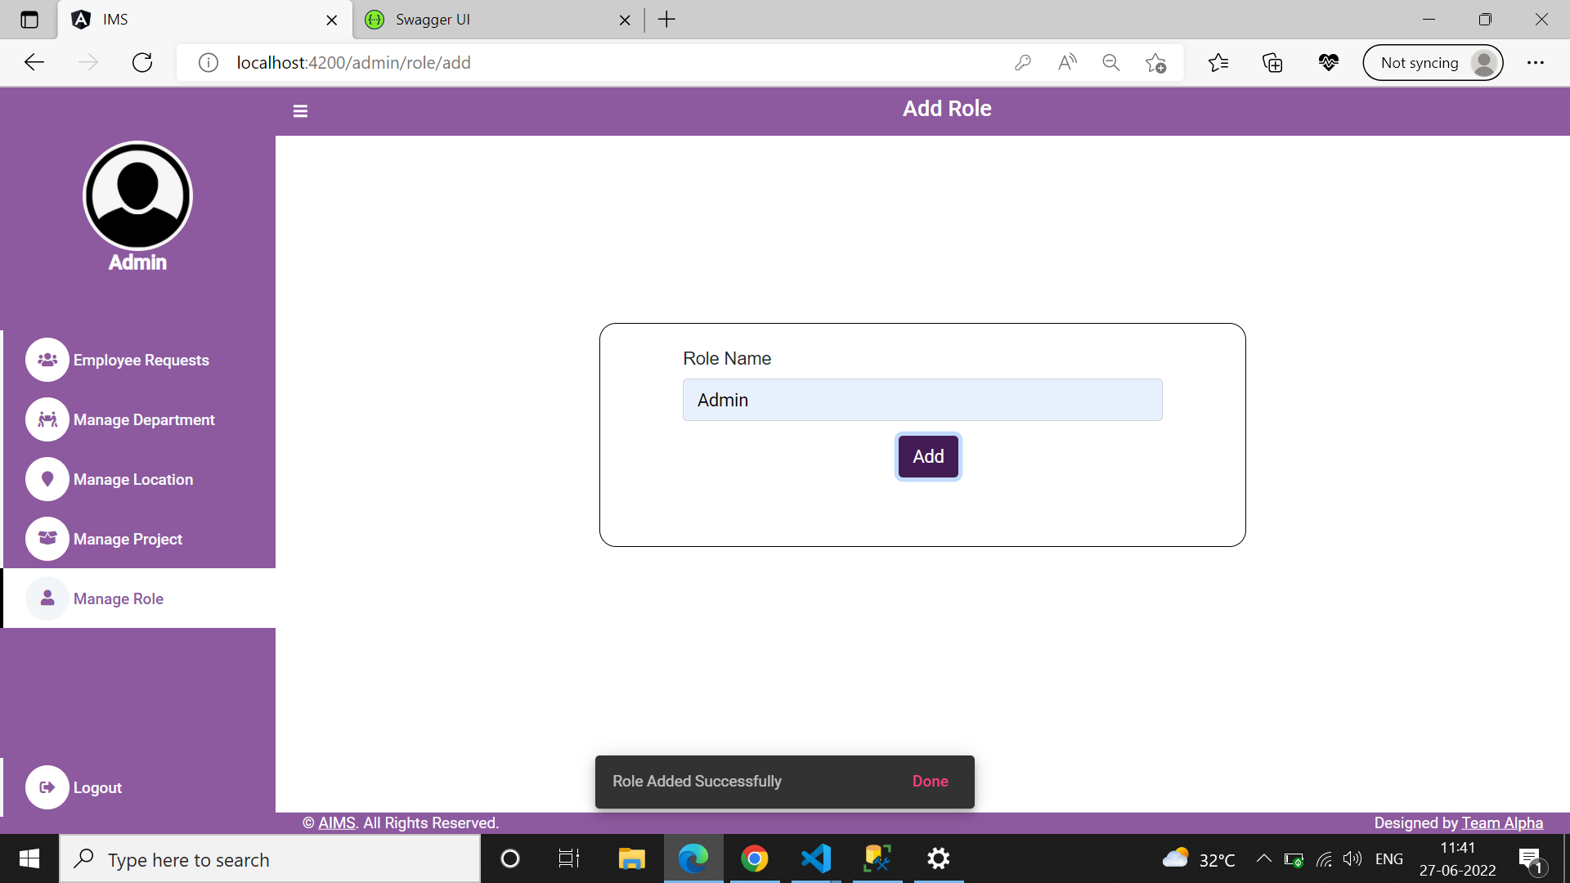

|  |  |
| --- | --- |
| Description | Purpose of the screen: Here admin able to add the Roles. |
| **Security Group** | List the security groups that may use the screen |
| **Data** | Admin have to enter Role that he/she wants to add and have to press add button. Required field validations are done here. |
| **Actions** | Add Button: Admin have to enter department name, then have to press add button to add the department. Once it’s added it notifies “Location added Successfully”. |

## Reports

|  |  |
| --- | --- |
| Description | Describe the purpose of the report as to ensure the client and developer agrees on its functionality. |
| **Security Group** | List the security groups that may use the report |
| **Data** | Describe each field in the report and how it is derived |
| **Groupings** | Describe how the report should be grouped and/or sorted |
| **Totals** | Describe the sub and grand totals needed on the report |
| **Filters** | Describe any filter or selection criteria needed for the report. How is this selection criteria entered? |
| **Export Formats** | Describe the export format of the report (print preview, printer, MS Word, MS Excel, HTML, etc.) |
| **Frequency** | If this report should be run periodically, specify the frequency (Daily, Weekly, Monthly, Quarterly, Yearly, On Demand) |

# Business Layer

< Define all of the objects necessary to support the presentation layer. First show the object hierarchy then include file that shows the details>

# Database Layer

<Define all of the tables/columns/views/stored procedures necessary to support the business layer along with an Entity-To-Relationship diagram. Include the ERD file that shows the details>

# Detailed Design to Functional Requirement Cross Reference Matrix

<To ensure all functional requirements have been captured in the detailed design, cross-reference each functional requirement with it’s associated Detailed Design element>

|  |  |
| --- | --- |
| **Functional Requirement** | **Detailed Design** |
| 7.1 Feature 2 | 7.1.1 Screen XYZ  7.2.1 Report XYZ |

# Build Process

< Details of Source Code, the tools used for uploading / downloading, build and publish locations etc>

# Definitions and Acronyms

| Abbreviation | Description |
| --- | --- |
|  |  |
|  |  |

# 